
Project Report
Project Title: Design of Biomedical Signal Conditioner: Heart Rate Noise filter
EECE-23
Section: B
Group: 04

Submitted by:
Name | Roll
Md. Abdullah Al Jihad | 202516057
Muhammad Ahnaf Shadid | 202516058
Raisa Anjum | 202516059
Abdullah Al Kafi | 202516060
Tamima Khan | 202516061

Submitted to:
Prof. Dr. Mohammed Hossam-E- Haider
Cdr Tania Islam Tani
Lec Raian Habib Himel
Lec Tareque Bashar Ovi

Contribution Table
Name | Roll | Contribution
Md. Abdullah Al Jihad | 202516057 | Component procurement,  Data procurement
Muhammad Ahnaf Shadid | 202516058 | Code, Documentation
Raisa Anjum | 202516059 | Design, presentation, debugging
Abdullah Al Kafi | 202516060 | Soldering, Assembly, Connection
Tamima Khan | 202516061 | Presentation, report, website

Introduction

The human heart generates electrical signals that can be recorded from the body surface as an electrocardiogram (ECG). These signals carry vital clinical information including heart rate, rhythmic abnormalities and myocardial ischemia. With the rapid expansion of wearable health monitors and point-of-care diagnostic devices, the ability to accurately acquire, condition, and process cardiac signals outside of a hospital setting has become increasingly important.
A fundamental challenge in acquiring biomedical signal is the presence of noise. ECG signals are weak, with a range of 0.5mV to 5mV and they get overwhelmed by environmental noise very easily. Without clean data, diagnosing a patient with heart disease becomes difficult. The objective of this project is to condition the incoming ECG signal and show clean data, making it easy to diagnose a patient.

Problem Statement

The primary problem addressed by this project is the corruption of heart rate signals by three dominant noise sources: baseline wander caused by patient respiration (0.05–0.5 Hz), powerline interference from the electrical grid (50 Hz in Bangladesh and much of Asia; 60 Hz in the Americas), and high-frequency EMG artifacts from muscle contractions (above 40 Hz). These noise components overlap with or flank the diagnostically relevant ECG frequency band, making passive or simple filtering insufficient.

Objectives

- To remove any noise received during ECG reading.
- To digitize the ECG signal using the ESP32's 12-bit ADC at a sampling rate of at least 360 Hz, sufficient to capture the clinically relevant features of the cardiac waveform.
- To implement a digital noise filter in embedded C/C++ (Arduino framework) to suppress residual noise in the digitized ECG signal, including baseline wander and high-frequency interference not fully eliminated by the AD8232's internal analog filters.
- To display the processed heart rate in real time via website and store the data of individual patients in CSV format for future analysis, validating correct end-to-end system operation.

Components

- ESP32
- AD8232 module
- Breadboard
- Electrode pad
- Jumper wires

System Overview

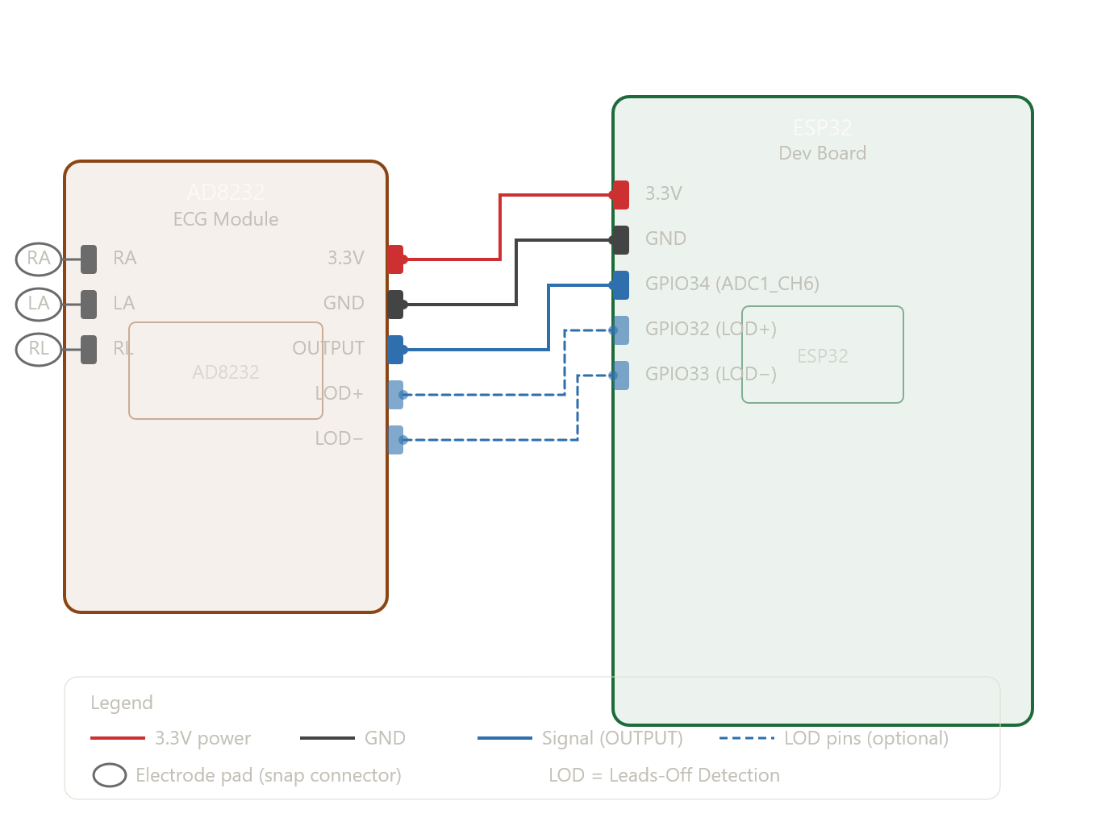

Block Diagram

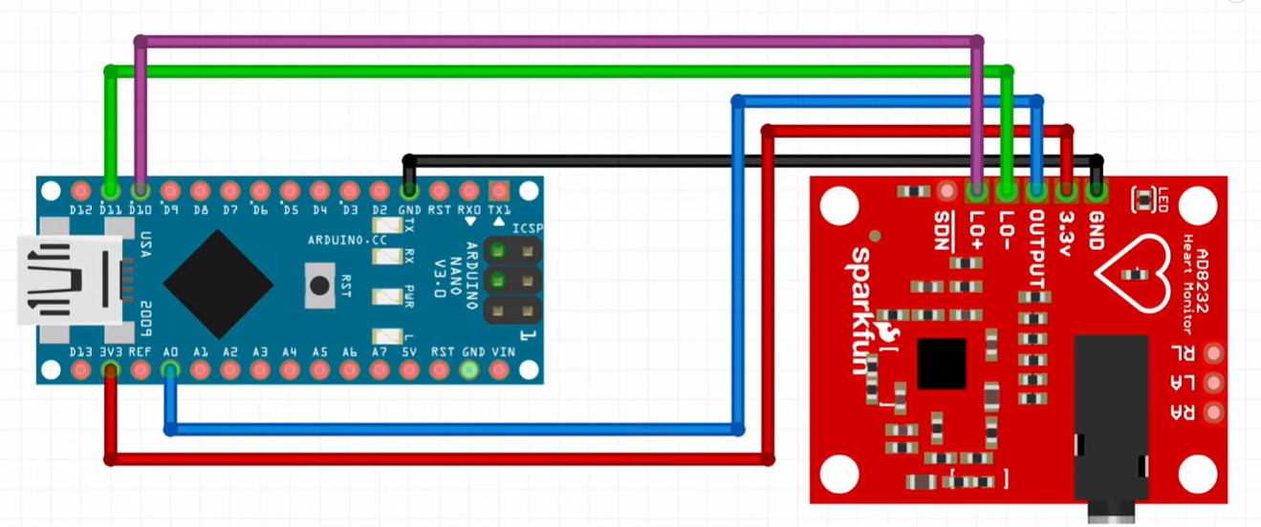

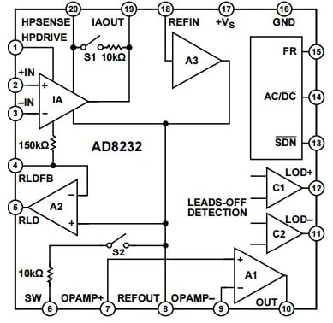
Functional Block Diagram of AD8232 Module

Methodology

This project follows a systematic pipeline in which a cardiac electrical signal is acquired from the human body, conditioned by dedicated analog hardware, digitized by a microcontroller, cleaned through software filtering, and finally processed to extract a real-time heart rate value. Each stage of this pipeline is described in detail below.
Stage 1 — Electrode Signal Acquisition: Surface electrodes placed on the body pick up the raw cardiac electrical signal.
Stage 2 — Analog Signal Conditioning (AD8232): The AD8232 module amplifies, filters, and outputs a clean analog ECG voltage.
Stage 3 — Analog-to-Digital Conversion (ESP32 ADC): The ESP32 samples the analog output of the AD8232 at a fixed rate using its built-in 12-bit ADC.
Stage 4 — Digital Noise Filtering: A software filter running on the ESP32 removes residual noise from the digitized signal.
Stage 5 — Data Display: The collected data is displayed on a website over the internet.
Stage 6 — Data Storage: The data is stored in a CSV file which is later used for patients’ health analysis.

Simulation Results
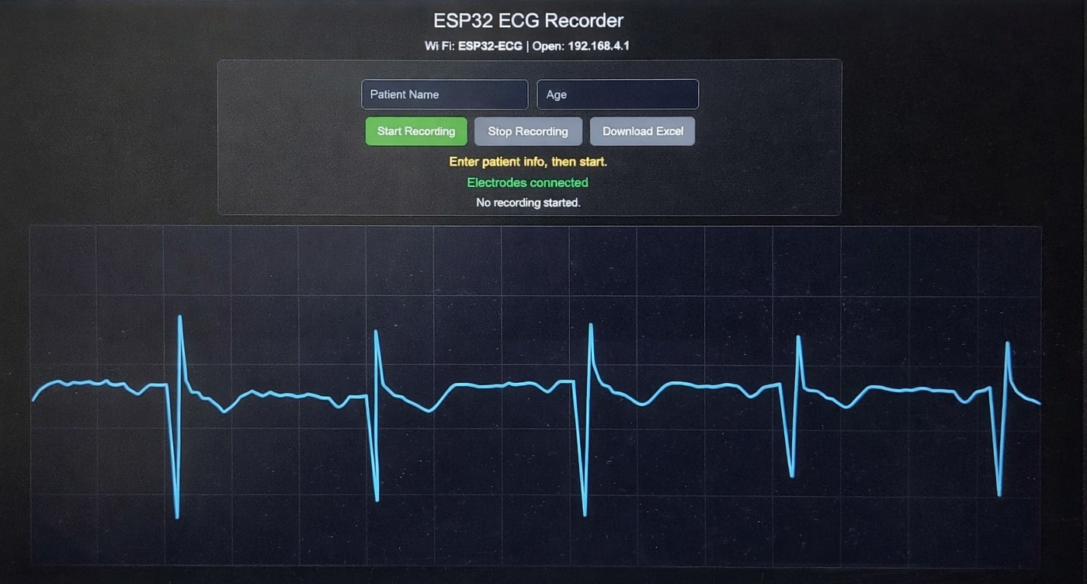

Result Analysis

- The device successfully removed noise from the input signal, fulfilling the salient criterion of the project.
- The result showed proper ECG of the subject, with crests and troughs varying with changes in breathing.
- The ECG had variations when there were muscle twitches, signifying that it is not entirely accurate.
- The module removes baseline wander (cutoff ~0.5 Hz in fast restore mode) and some high-frequency noise (cutoff ~40 Hz).
- The module actively cancels common-mode powerline interference.
- Since the module amplified the signal, which is why the signal is interpretable.

Discussion

The project successfully demonstrated a complete end-to-end ECG monitoring system using low-cost, readily available components. The integration of the AD8232 ECG module, the ESP32 microcontroller, digital signal filtering, and a browser-based web interface produced a fully functional heart rate monitoring solution that required no dedicated medical equipment, no external software installation, and no internet connection to operate. The system met all its defined objectives and additionally produced an output method — the live web interface — that exceeded the originally planned scope of the project. The AD8232 module proved to be a highly effective analog front-end solution for this application. Its internal instrumentation amplifier successfully amplified the weak differential ECG signal from the surface electrodes to a level suitable for analog-to-digital conversion, while its built-in right leg drive circuit actively reduced common-mode 50 Hz powerline interference at the input stage. The internal analog band-pass filter, with a passband of 0.5 Hz to 40 Hz, eliminated the need to design a separate analog filter circuit, significantly reducing the hardware complexity of the overall system. The output voltage range of 0 V to 3.3 V was directly compatible with the ESP32 ADC input without requiring any additional level shifting or impedance matching components. The leads-off detection pins provided a practical mechanism for identifying poor or broken electrode contact during operation, which is an important usability and safety feature in any real-world monitoring device. The decision to implement a browser-based web interface served by ESP32's own Wi-Fi access point proved to be one of the most practical and effective design choices in this project. Rather than relying on a small physical display module such as an OLED or TFT screen, the web interface allowed the live ECG waveform and BPM reading to be viewed on any device with a browser, including smartphones, tablets, and laptops, without requiring any application to be installed. This made the system significantly easier to demonstrate and interact with, and gave the output display a much larger and more readable form than any embedded screen of comparable cost could provide.

Future Scope

Custom PCB Design
The current prototype can be converted into a compact PCB integrating the ESP32, AD8232, power supply, and supporting circuitry to make the device smaller, more reliable, and easier to use.
Mobile App Integration
Instead of only using a browser-based interface, the system can be connected to a dedicated Android or iOS app for easier monitoring, patient management, and report viewing.
Cloud Storage and Remote Monitoring
ECG data can be uploaded to a cloud database so that doctors or family members can monitor patients remotely in real time.
AI-Based Abnormality Detection
Collected ECG data can be used to train machine learning models to detect abnormalities such as arrhythmia, tachycardia, and bradycardia automatically.

